Partial / residual correlation: USDJPY and EURGBP
Method 07 / daily log returns / leave-currency-out USD factor / Alpari D1 full available history

Study setup
Logical pair: USDJPY , EURGBP
Broker symbols: USDJPY_i , EURGBP_i
Snapshot: 2026-11-03_majors_alpari_D1
Timeframe: D1
Matched return window: 1999-01-06 to 2026-11-02 (UTC bar dates)
Matched return count n: 7129
Dropped unfinished last bar dated 2026-11-03 UTC after a tick-volume check against the prior complete day.
USD-strength sign rule: minus log return when USD is the quote (EURUSD, GBPUSD, AUDUSD, NZDUSD); plus log return when USD is the base (USDJPY, USDCHF, USDCAD). EURGBP is never a constituent.
Control z constituents (4): AUDUSD, NZDUSD, USDCHF, USDCAD
z_t = equal-weight mean of those USD-strength returns on the same day
Complete matched rows (Excel): USDJPY-EURGBP_Partial_D1.xlsx
Complete matched rows (HTML table): USDJPY-EURGBP_Partial_D1_data.html

Method carried forward
Partial / residual correlation regresses each matched daily log return of close, ln(close_t / close_t-1), on the same leave-currency-out USD strength factor z, then takes Pearson correlation of the two residual series. Quotes are not inverted. z is the equal-weight mean of USD-strength returns from other majors that do not share a non-USD currency with either leg; EURGBP is never a constituent. USD-strength is minus the log return when USD is the quote (EURUSD, GBPUSD, AUDUSD, NZDUSD) and plus the log return when USD is the base (USDJPY, USDCHF, USDCAD). OLS uses an intercept on each leg. rho_partial is symmetric under swap of the two symbols. It describes leftover linear co-movement after removing linear z; it is not a cause, not a lead, and not a trading signal. Daily rows are not independent and residuals are estimated, so the two-sided p-value and Fisher interval are secondary. Same-sample raw Pearson r is a side check only.

Regression on z
leg | intercept_a_or_c | slope_b_or_d | R2
USDJPY | 5.944e-05 | 0.23154349 | 0.04136747
EURGBP | 2.039e-05 | -0.11327385 | 0.01609427

Results
rho_partial: -0.106744
Two-sided p-value: 1.61041e-19
Approximate 95% Fisher interval: [-0.129636, -0.083737]
Same-sample raw Pearson r: -0.129471
rho_partial minus r: 0.022727

Conclusion
Over 7129 matched daily rows for USDJPY and EURGBP after removing a leave-currency-out USD factor built from 4 constituents, rho_partial is -0.1067 (negative, weak residual linear link in this sample). Approximate 95% Fisher interval: [-0.1296, -0.0837]. Same-sample raw Pearson r is -0.1295 (partial minus r = 0.0227). Leg R-squared on z: USDJPY=0.0414, EURGBP=0.0161. Two-sided p under the usual independent-pairs model is 1.61e-19; residuals are estimated and daily FX rows are linked, so treat p as secondary. This does not establish cause, lead-lag, or a lasting trading rule.

Charts
Daily closes
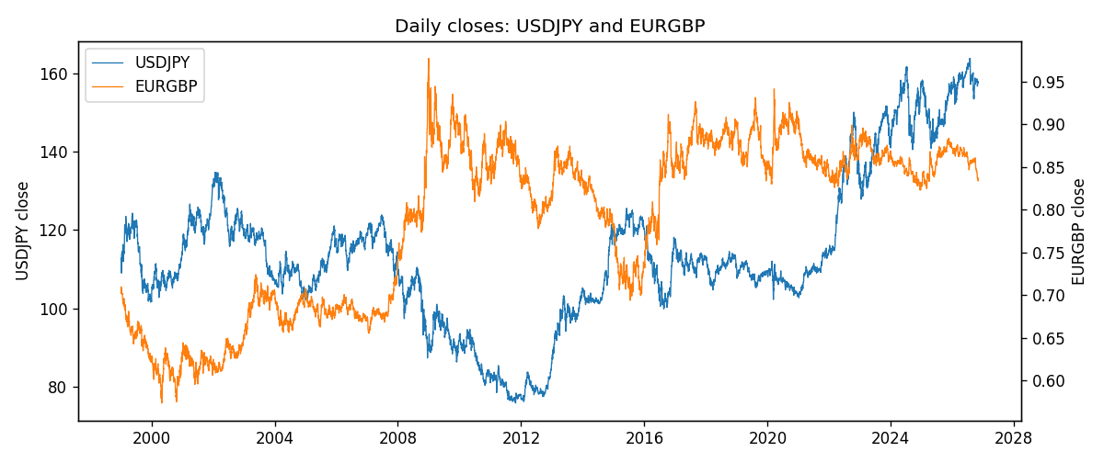
Log returns and control z
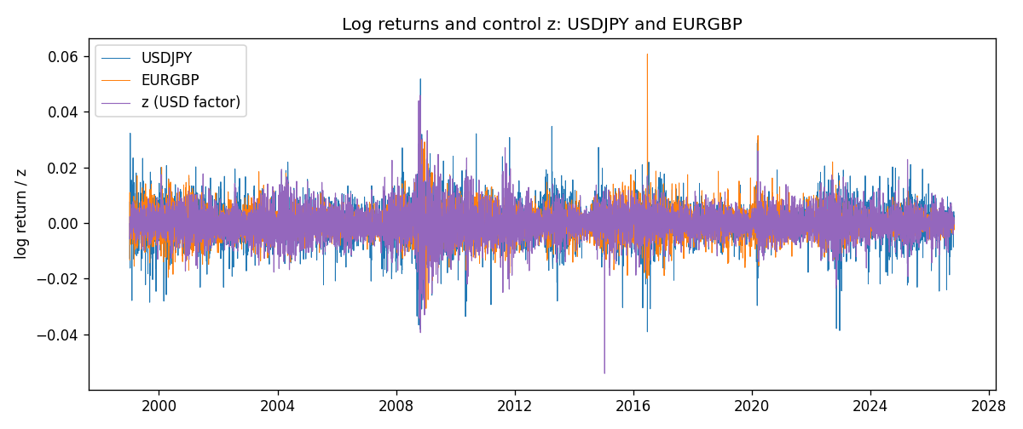
Residual scatter e_x vs e_y
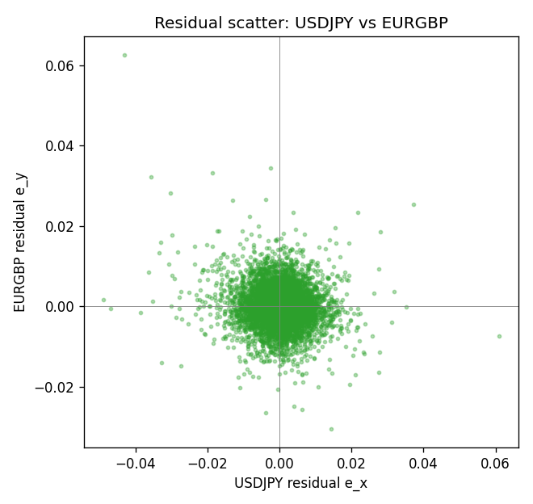

Data report
Every matched row that entered the partial correlation is stored in the sibling Excel workbook named USDJPY-EURGBP_Partial_D1.xlsx. That file is the complete data archive for redrawing charts. Embedding all rows as a Word table is impractical at this length; the Word file holds the column list, column summaries, and the first and last 15 matched rows.
Columns: time, USDJPY_open, EURGBP_open, USDJPY_high, EURGBP_high, USDJPY_low, EURGBP_low, USDJPY_close, EURGBP_close, USDJPY_tick_volume, EURGBP_tick_volume, USDJPY_spread, EURGBP_spread, USDJPY_real_volume, EURGBP_real_volume, USDJPY_log_return, EURGBP_log_return, usd_strength_AUDUSD, usd_strength_NZDUSD, usd_strength_USDCHF, usd_strength_USDCAD, z, USDJPY_fitted, EURGBP_fitted, USDJPY_resid, EURGBP_resid
Column summaries (matched calculation rows)
column | count | mean | std | min | 25% | 50% | 75% | max
USDJPY_open | 7129 | 113.80171 | 19.289279 | 75.693 | 104.301 | 110.964 | 120.745 | 163.824
EURGBP_open | 7129 | 0.78787915 | 0.09637748 | 0.5734 | 0.6884 | 0.83444 | 0.8655 | 0.9769
USDJPY_high | 7129 | 114.29888 | 19.351009 | 76.001 | 104.824 | 111.42 | 121.29 | 163.978
EURGBP_high | 7129 | 0.79096121 | 0.09675282 | 0.5789 | 0.6905 | 0.83739 | 0.86841 | 0.9799
USDJPY_low | 7129 | 113.27917 | 19.216807 | 75.402 | 103.815 | 110.515 | 120.2 | 163.628
EURGBP_low | 7129 | 0.78517685 | 0.09619509 | 0.5682 | 0.6863 | 0.83221 | 0.86303 | 0.9661
USDJPY_close | 7129 | 113.81512 | 19.304485 | 75.811 | 104.3 | 110.98 | 120.71 | 163.851
EURGBP_close | 7129 | 0.78792406 | 0.09637588 | 0.5735 | 0.6884 | 0.83444 | 0.86555 | 0.977
USDJPY_tick_volume | 7129 | 107114.1 | 179930.04 | 197 | 10049 | 53568 | 93203 | 1803508
EURGBP_tick_volume | 7129 | 87747.814 | 145877.32 | 332 | 6718 | 44856 | 82002 | 1424684
USDJPY_spread | 7129 | 20.098752 | 17.551721 | 0 | 6 | 11 | 30 | 50
EURGBP_spread | 7129 | 21.135222 | 19.050893 | 0 | 4 | 13 | 40 | 50
USDJPY_real_volume | 7129 | 3.504681e+10 | 1.6153804e+11 | 0 | 0 | 0 | 0 | 3.8834203e+12
EURGBP_real_volume | 7129 | 2.8078235e+10 | 1.3570431e+11 | 0 | 0 | 0 | 0 | 3.5726265e+12
USDJPY_log_return | 7129 | 5.124e-05 | 0.0062132 | -0.03908203 | -0.00320044 | 0.00012446 | 0.00340927 | 0.05184024
EURGBP_log_return | 7129 | 2.44e-05 | 0.00487311 | -0.03067367 | -0.00262262 | -9.978e-05 | 0.00256826 | 0.06075387
usd_strength_AUDUSD | 7129 | -3.429e-05 | 0.00755471 | -0.0806166 | -0.004155 | -0.00029309 | 0.00384986 | 0.08602525
usd_strength_NZDUSD | 7129 | -2.603e-05 | 0.00764647 | -0.05966839 | -0.0045915 | -0.00024088 | 0.00423176 | 0.07027433
usd_strength_USDCHF | 7129 | -7.228e-05 | 0.00659123 | -0.19545699 | -0.00334859 | 7.816e-05 | 0.00331593 | 0.09051364
usd_strength_USDCAD | 7129 | -9.1e-06 | 0.00514798 | -0.03859748 | -0.00283484 | 5.567e-05 | 0.00272835 | 0.03436319
z | 7129 | -3.543e-05 | 0.00545774 | -0.05405838 | -0.00305759 | -0.00011894 | 0.00298984 | 0.04593428
USDJPY_fitted | 7129 | 5.124e-05 | 0.0012637 | -0.01245742 | -0.00064852 | 3.19e-05 | 0.00075172 | 0.01069523
EURGBP_fitted | 7129 | 2.44e-05 | 0.00061822 | -0.00518276 | -0.00031828 | 3.386e-05 | 0.00036673 | 0.00614379
USDJPY_resid | 7129 | 0 | 0.00608333 | -0.04887137 | -0.00300978 | 0.00014974 | 0.0030988 | 0.06089611
EURGBP_resid | 7129 | -0 | 0.00483374 | -0.03050123 | -0.0026585 | -0.0001253 | 0.00253359 | 0.06265612
First 15 matched rows (selected columns)
time | USDJPY_close | EURGBP_close | USDJPY_log_return | EURGBP_log_return | z | USDJPY_fitted | EURGBP_fitted | USDJPY_resid | EURGBP_resid
1999-01-06 | 112.77 | 0.7019 | 0.0075660159 | -0.013303338 | -0.00015173409 | 2.4310013e-05 | 3.7577136e-05 | 0.0075417059 | -0.013340915
1999-01-07 | 111.33 | 0.7097 | -0.012851583 | 0.011051402 | -0.0057573794 | -0.0012736407 | 0.00067255015 | -0.011577942 | 0.010378852
1999-01-08 | 110.8 | 0.7062 | -0.0047719894 | -0.004943862 | 0.0023073886 | 0.00059370387 | -0.00024097716 | -0.0053656933 | -0.0047028849
1999-01-11 | 109.02 | 0.7053 | -0.016195423 | -0.0012752393 | -0.0039323161 | -0.00085105913 | 0.0004658182 | -0.015344364 | -0.0017410575
1999-01-12 | 112.6 | 0.7077 | 0.032310364 | 0.0033970309 | 0.0017421273 | 0.00046282129 | -0.00017694783 | 0.031847543 | 0.0035739787
1999-01-13 | 113.52 | 0.708 | 0.0081373171 | 0.00042381861 | 0.0010366886 | 0.00029948155 | -9.7040075e-05 | 0.0078378356 | 0.00052085869
1999-01-14 | 113.52 | 0.7066 | 0 | -0.0019793588 | 0.0018486377 | 0.00048748307 | -0.00018901267 | -0.00048748307 | -0.0017903461
1999-01-15 | 114.15 | 0.7012 | 0.0055343401 | -0.0076715819 | 0.0014678885 | 0.00039932307 | -0.00014588374 | 0.0051350171 | -0.0075256981
1999-01-18 | 114.16 | 0.7017 | 8.7600193e-05 | 0.00071280921 | -0.00032208601 | -1.5133863e-05 | 5.6873553e-05 | 0.00010273406 | 0.00065593566
1999-01-19 | 113.52 | 0.7007 | -0.0056219403 | -0.0014261269 | -0.0016015737 | -0.00031139091 | 0.00020180605 | -0.0053105494 | -0.0016279329
1999-01-20 | 112.91 | 0.7021 | -0.0053879917 | 0.0019960086 | -0.0010172128 | -0.00017608594 | 0.00013561324 | -0.0052119057 | 0.0018603954
1999-01-21 | 113.87 | 0.7016 | 0.0084664056 | -0.00071240297 | -0.0032373469 | -0.00069014354 | 0.00038709637 | 0.0091565492 | -0.0010994993
1999-01-22 | 114.56 | 0.7004 | 0.0060412564 | -0.0017118406 | 0.0066664112 | 0.0016030072 | -0.00073474041 | 0.0044382492 | -0.00097710023
1999-01-25 | 113.72 | 0.6966 | -0.0073594164 | -0.0054402425 | 0.0027050132 | 0.00068577124 | -0.00028601762 | -0.0080451877 | -0.0051542249
1999-01-26 | 113.86 | 0.6962 | 0.0012303367 | -0.00057438255 | -0.0013659231 | -0.00025682754 | 0.00017511299 | 0.0014871643 | -0.00074949555
Last 15 matched rows (selected columns)
time | USDJPY_close | EURGBP_close | USDJPY_log_return | EURGBP_log_return | z | USDJPY_fitted | EURGBP_fitted | USDJPY_resid | EURGBP_resid
2026-10-13 | 158.305 | 0.84458 | -0.0018932826 | 0.00020130374 | -0.0038421288 | -0.00083017684 | 0.00045560234 | -0.0010631057 | -0.0002542986
2026-10-14 | 158.317 | 0.84553 | 7.5800166e-05 | 0.0011241873 | 0.0024268193 | 0.00062135726 | -0.00025450553 | -0.00054555709 | 0.0013786928
2026-10-15 | 158.024 | 0.84479 | -0.0018524319 | -0.00087557391 | -0.0026536155 | -0.00055498432 | 0.00032097486 | -0.0012974476 | -0.0011965488
2026-10-16 | 157.964 | 0.84307 | -0.00037976126 | -0.0020380844 | -0.0040490076 | -0.00087807828 | 0.0004790363 | 0.00049831702 | -0.0025171207
2026-10-19 | 158.517 | 0.84259 | 0.0034946841 | -0.00056950988 | -0.0013065168 | -0.00024307239 | 0.00016838381 | 0.0037377565 | -0.00073789369
2026-10-20 | 158.16 | 0.83957 | -0.0022546642 | -0.0035906254 | -0.003379175 | -0.00072298291 | 0.00040316179 | -0.0015316813 | -0.0039937872
2026-10-21 | 158.108 | 0.83839 | -0.00032883504 | -0.00140647 | -0.0019865409 | -0.00040052755 | 0.00024541276 | 7.1692508e-05 | -0.0016518828
2026-10-22 | 156.755 | 0.83682 | -0.0085942669 | -0.0018743924 | -0.0007158966 | -0.00010631814 | 0.00010148199 | -0.0084879487 | -0.0019758744
2026-10-23 | 156.81 | 0.83751 | 0.00035080446 | 0.00082421033 | 5.2879402e-05 | 7.1686935e-05 | 1.4399779e-05 | 0.00027911753 | 0.00080981055
2026-10-26 | 157.458 | 0.83762 | 0.0041238746 | 0.00013133309 | 0.0020001446 | 0.00052256352 | -0.00020617445 | 0.0036013111 | 0.00033750754
2026-10-27 | 157.894 | 0.83595 | 0.0027651658 | -0.0019957343 | 0.00093625232 | 0.00027622618 | -8.5663269e-05 | 0.0024889396 | -0.0019100711
2026-10-28 | 157.743 | 0.83651 | -0.00095679538 | 0.00066967224 | 0.00019617471 | 0.00010486603 | -1.8318314e-06 | -0.0010616614 | 0.00067150408
2026-10-29 | 157.683 | 0.83553 | -0.00038043789 | -0.0011722209 | -0.0003781836 | -2.8122895e-05 | 6.3227943e-05 | -0.00035231499 | -0.0012354488
2026-10-30 | 157.516 | 0.83351 | -0.0010596481 | -0.0024205543 | -0.00037988557 | -2.8516977e-05 | 6.3420733e-05 | -0.0010311312 | -0.002483975
2026-11-02 | 157.933 | 0.83426 | 0.0026438521 | 0.00089940465 | 0.00024600261 | 0.00011640336 | -7.4760301e-06 | 0.0025274487 | 0.00090688068

